Installing Mochasoft to connect to Audinet
- Download the latest install files from audiportal.com.au
http://audiportal.com.au/it/DocumentManager/downloads/Mochasoft/1396298866/
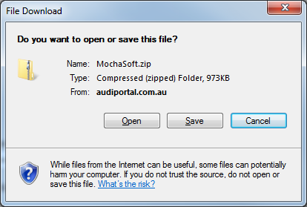
- Save the file to any location and unpack all files
- Run MochaSoft.msi to start install, accepting all default values.
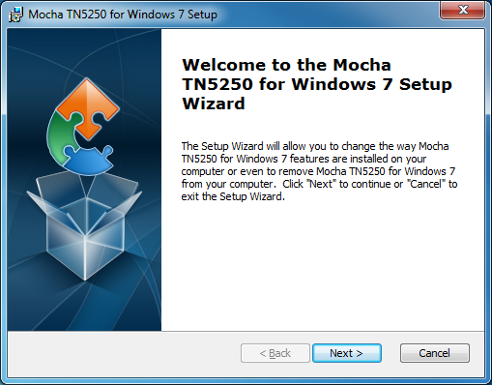
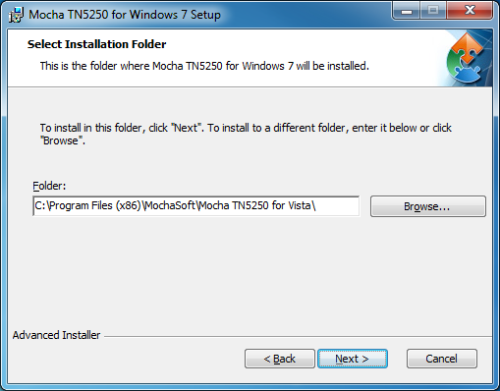
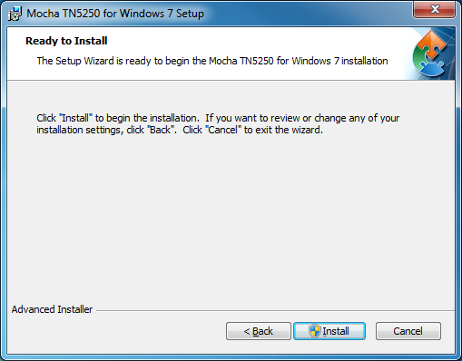
3. Once the installation has finished, launch the application.
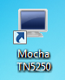
4. To install the license Click Tools > License and input the information as below, this is also in a text file so you can copy and paste the information in as required
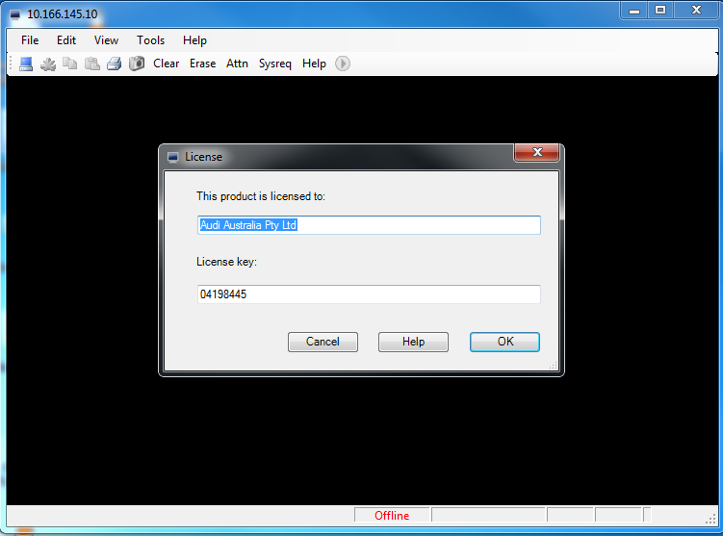
- Click File > Edit/New Session
Enter the information as below to set-up the connection and press connect
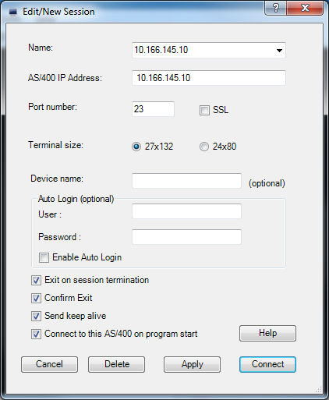
You are now connect to Audinet
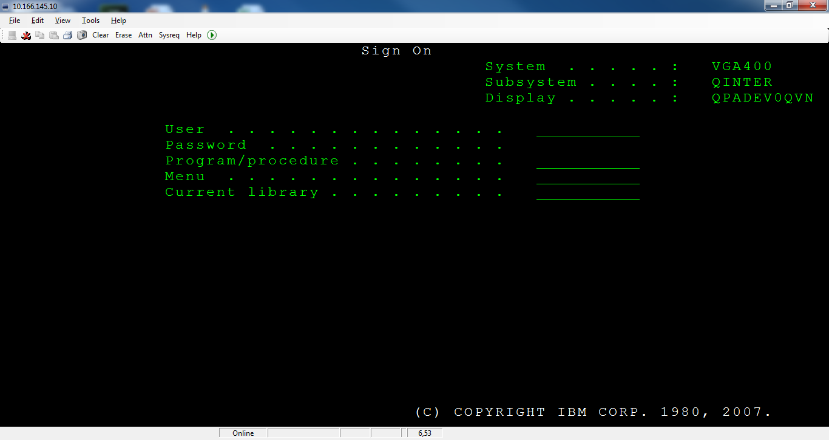
Extra information:
To Modify Keyboard layout
Tools > Keyboard layout
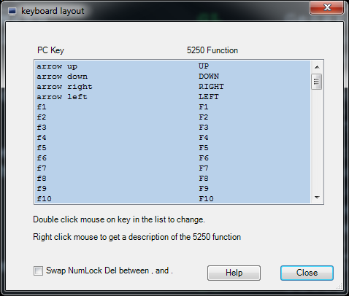
Change Colours
Tools > Options
